**Student Organization Resource Packet**

# **Event Forms**

## Pre-Event Form

Prior to posting fliers and requesting funds from Student Government for an event, a [pre-event form](https://my.msoe.edu/ICS/Campus_Life/Student_Organization_Event_Submission.jnz) must be filled out. The form may be found through the My.MSOE.edu portal under the Campus Life tab. Filling this form out also adds your event to the Student Life shared calendar and grants you a place in the Weekly Digest emails. Fill out all the required fields in the form with information as accurately as possible. After completing the form, you will receive a confirmation email that the event has been created and accepted. You may submit a revision form later if there are changes to the event that would be pertinent to reflect in the Student Life shared calendar and/or Weekly Digest. Note that there are no longer post-event forms.

# **Student Life Event Calendar**

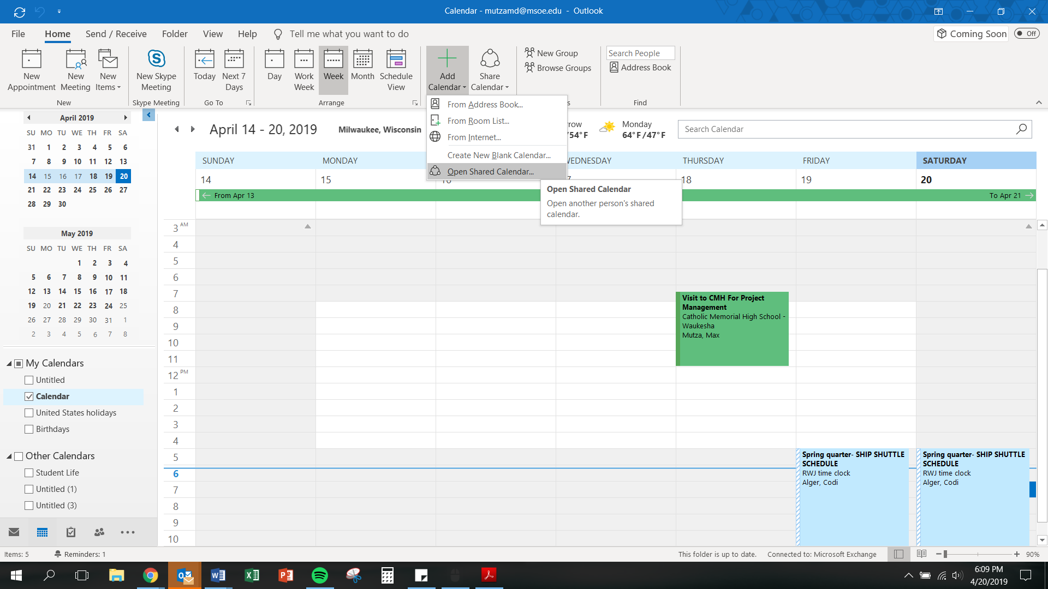

*❶*

Student Life maintains an updated and shared Outlook calendar with all the events submitted using the Pre-Event form linked above. This proves to be a useful resource when planning events. It allows you to select the best date with the fewest conflicts to maximize attendance at your events and meetings. Note that this calendar is designed as an event-planning resource and is not intended to be used to help advertise your events. Please see the procedure below on how to open this shared calendar in Outlook.

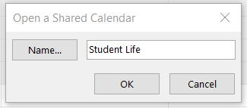

*❷*

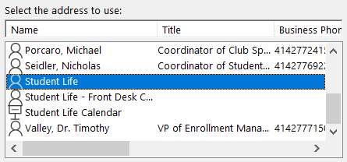

*❸*

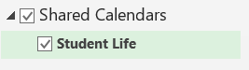

*❹*

* From your **Calendar** folder, on the **Home** menu, select **Add Calendar**, then select **Open Shared Calendar…**
* Enter “**Student Life**” as the name of the calendar you wish to open, then select **OK**
* Scroll to the bottom of the calendar options and select the person named “**Student Life**” (Do NOT select the options titled “Student Life – Front Desk Calendar” or “Student Life Calendar”), then select **OK**
* The shared “**Student Life**” calendar should now appear next to your personal calendar and will be stored in your “**Shared Calendars**”

# **Advertising**



*Acceptable*

*Unacceptable*

## How to Get Advertising Approved

Any posted advertisements must be approved and stamped by Student Life in CC377. It is recommended that you have one master copy stamped and photocopy all other fliers from that original copy. Certain organizations may be authorized to include the approval and post until dates within the poster itself; however, this option is not available for all organizations. This discrepancy is at the discretion of the Student Life professional staff. Any and all non-approved advertisements will be removed from their posted locations.

## Printing Color Advertisements

Student Organizations may print up to 60 color fliers per event for free through the Student Life Office once they have completed the pre-event form. Posters printed in Student Life must be free from large saturated colors, backgrounds, and other ink-heavy objects (See examples to the right). Additional color fliers may be printed through the Follow You Printing service at the color printer located on the second floor of the library for 30 cents per page, or from an external printer (i.e. a personal printer or at a print shop). You may also print black and white posters onto colored paper for free using the regular Follow You Printing printers.

## Where You Can Post Fliers

Fliers and other paper advertisements may only be posted on public bulletin boards around campus. You may not post fliers on department bulletin boards unless approved by the corresponding department. If fliers are posted to walls or other non-bulletin-board surfaces, they must be attached using painters tape (no duct tape, scotch tape, etc.). Posting signs in nonapproved locations is prohibited. These may include, but are not limited to: doors, windows, hallways, walls of buildings, poles, tables, bathroom doors, and trees. You can also make tri-fold paper advertisements to place on tables around campus subject to approval from the location’s governing department. In order to post fliers in the Kern Center you must submit them to the Kern Center front desk. Approximately 10 posters are sufficient to cover the main areas.

## Printing and Posting Large Banner Advertisements

Large advertisements may be printed using plotters from the IT Department. By either giving a digital file of your flier to the IT helpdesk on a USB drive, emailing the attachment to [helpdesk@msoe.edu](mailto:helpdesk@msoe.edu) with the specified size, or submitting an [IT ticket](https://helpdesk.msoe.edu/support/home), they will gladly print it for you. **[Vice President Tanneberger can do this for us]** The dimensions for this poster can be up to 36” by any length (by authorized request). The recommended size is 36"x48." IT prefers the document to be either a PDF or PPT file. Depending on how busy they are, it may take IT up to a few hours to get a large banner printed. Please be patient with them during busy times and follow their instructions for banner pickup times and locations. You will likely be asked to pick up your poster in CC71. This room is protected with an ID card scanner, but as a student you should have access.

When you are ready to hang your advertisement in the CC, get some washer weights from Student Life, tape them to the bottom of the back of your poster, and hang it from the mezzanine using blue painters’ tape. If you wish to hang a large poster in the residence halls, please contact Kristen Landaal (RWJ/Regents - [landaal@msoe.edu](mailto:landaal@msoe.edu)) or Mark Hargrove (MLH/Tower - [hargrove@msoe.edu](mailto:hargrove@msoe.edu)). **[ I would contact Betty Albrecht and Rick Gagliano,** [**living@msoe.edu**](mailto:living@msoe.edu)**]**

## How to Advertise in the Residence Halls

All posters and mailbox ads must be approved by a Residence Life Hall Director before they may be distributed in the residence halls. Thus, you must first bring fliers (≈25 copies for RWJ/Regents and ≈20 copies for MLH/Tower) and/or mailbox ads (≈275 copies for RWJ/Regents and ≈225 copies for MLH/Tower) to the Residence Life office located on the ground floor of either RWJ or MLH respectively. Your advertisements may then be approved and distributed accordingly by the Residence Life staff. Note that you are NOT allowed to post advertisements in the residence halls by yourself. All distribution of advertisements is done solely by the Residence Life staff.

Apart from paper advertising, you may also advertise your organization or event by hosting a table in the RWJ Café during meal hours. To set up a table in this manner, you must first get approval from the RWJ Hall Director, Kristen Landaal ([landaal@msoe.edu](mailto:landaal@msoe.edu)), and the Director of A’viands Food Services, Daryl Anderson ([darryl.anderson@aviands.com](mailto:darryl.anderson@aviands.com)) **[Contact Betty Albrecht or Jeff Lataille, manager for ADC. This information is very outdated. Could/should still reach out to Kristen Landaal]**. Another great way to engage students involves coordinating floor events with organization events. Feel free to reach out to Residence Assistants if you wish to work together in planning an event.

## E-Mail Advertisements

Student organizations are generally granted 1-2 All Student e-mails per year to promote their signature event(s). Please contact the Student Life office for inquiries and authorization regarding such e-mails.

## Taking Down Your Fliers

Student Organizations are responsible for taking their fliers down within 3 days of the “Post Until:” date printed on the fliers when they are approved by Student Life. Fliers in the residence halls will be removed by the Residence Life staff accordingly. Failure to adhere to any of the above posting policies may result in the loss of future posting privileges.

## How to Post on TVs

If your student organization has the ability to design digital board advertisements, there are opportunities to promote your event on the TVs in the Campus Center. The dimensions of the digital advertising need to be 1920 x 1080 (same size as a high-def screen) to display properly. The resolution should be 72 dpi and higher. The format of the image can be JPG or PNG. Include the Who, What, When, Where, Why, and Cost (if any) for the event. Bold font will help make the sign readable from further away. Try not to be wordy, because you want to convey the essential info quickly. There should be clear contrast between your background colors and the color of the text. Completed ads may be sent to the Manager of Multimedia & Videos, Kent Peterson ([peterson@msoe.edu](mailto:peterson@msoe.edu)). For more information contact Kent Peterson in the Marketing Department.

# **Funding**

All student organizations approved by Student Government may request funds. Below is a breakdown of Student Government’s annual budget.

|  |  |
| --- | --- |
| ***Category*** | ***Budget*** |
| SUB Funding Allocations | $ 8,000.00 |
| Student Organization Promotion | $ 2,000.00 |
| Student Development / Conferences | $ 5,000.00 |
| General Budget – Quarter 1 | $ 5,000.00 |
| General Budget – Quarter 2 | $ 5,000.00 |
| General Budget – Quarter 3 | $ 5,000.00 |
| **Total (Annual)** | **$ 30,000.00** |

In general, Student Government **CAN** fund the following:

* Events that benefit the MSOE community and are open to all undergraduate students
* Advertising and publicity to build organizational participation and student involvement
* Developmental conference expenses, given your organization hosts a campus-wide informational session sharing what was learned

In general, Student Government **CANNOT** fund the following:

* Non-registered organizations
* Senior design, course projects, personal projects, etc.
* Donations for fundraising and charitable events
* Operating expenses and fees (i.e. entry, national, etc.)
* Funds that have already been spent (i.e. requesting funds for an event after it has occurred)

Typical funding requests are allotted between $5 and $10 per attendee; however, all funding requests are approved or denied on an individual basis. Special situations and circumstances will be considered.

## How to Request Funds

Funds may be requested at Student Government General Assembly Meetings held in the MPR every Monday from 1:00 PM – 1:50 PM, Weeks 1-10. Send a representative of your student organization to one of these meetings and prepare to discuss your request for funds and answer any questions the senate may have. It is recommended that you email Student Government ([SGA@msoe.edu](mailto:SGA@msoe.edu)) stating that you will be requesting funds prior to the meeting you attend. This should ensure that your request will be on the agenda for said meeting. It is also recommended that you provide the Senate and Cabinet (≈15 copies) with a budget breakdown spreadsheet at the meeting.

If the Senate approves your request by a simple majority, you will need to meet with the Student Government Treasurer, Ashleigh Gimenez ([gimenezar@msoe.edu](mailto:gimenezar@msoe.edu)) **[ Lexi Such ]**, to receive your reimbursement form. Student Government is only able to reimburse for funds spent. You must keep all your receipts to turn in for reimbursement. In special cases, Student Life may be able to provide funds up-front (when exceeding $500+).

## External Funding

For any regards relating to fundraising, crowdfunding, donations (material or monetary), or any other form of solicitation, students must first go through the Student Life office to make arrangements with the Development Office. Students should not go directly to the Development Office for assistance.

## Selling Tickets for Events

If you would like to sell tickets for an event, you may sell them in-person without issues. If desired, you can also utilize CASHNet as a resource for selling tickets online. Ultimately, online tickets sales will be set up through IT, but coordination for these sales should be facilitated through Student Life.

# **Room Reservations**

Room reservations for locations across campus (i.e. classrooms, event spaces, etc.) may be requested through [CollegeNET 25Live](http://rooms.msoe.edu). You will be asked to login using your MSOE Single Sign On credentials. From this page you will be prompted to select one of five different options: See Available Locations, Create an Event, Search for Events, See Available Resources, and Search for Organizations.

Once you have determined the date, time, location, and resources for your event, reservations may be made using the “Create an Event” option. Fortunately, CollegeNET 25Live is equipped with copious resources to aid navigating its interface. The “Help” button on the upper right-hand corner of the page may be used at any time for assistance with room and resource reservations. Once you have made a request for a room reservation it will be placed on the docket for a request-approving member of MSOE’s professional staff. You will be notified by e-mail whether your room request is approved or denied. It is recommended that you request room reservations as soon as possible to ensure scheduling conflicts do not arise. If your event requires complex setup or resource requests, Student Life should be contacted for assistance.

# **Policies**

## Van Training and Certification

Students with a regular (non-probationary) driver’s license may be certified to drive the MSOE Athletic Vans. The certification process takes approximately 2.5 hours, which includes 1.5 hours of classroom discussion and a 1-hour on-the-road test. Classes and driving sessions may be scheduled with Nick Seidler ([seidler@msoe.edu](mailto:seidler@msoe.edu)). An authorization form must be signed by an adviser or coach, and a photocopy of the front and back of your driver’s license is required. Human Resources will then review your driving history and either approve or deny your van certification.

## Van Reservations

Contact Chuck Stollenwerk ([stollenwerk@msoe.edu](mailto:stollenwerk@msoe.edu)) to reserve athletic vans for events requiring transportation. These reservations are subject to the athletics schedule and may not always be available. A driver who is certified to drive the vans is required to reserve and drive the vans.

## Travel Policy and Risk Management

If you are traveling more than 100 miles, doing an activity that has higher than average day-to-day risk, and/or involves staying overnight for an event, it is required that the group meet with Nick Seidler in Student Life to fill out a travel form and get release forms for each attendee. This should be completed at least two weeks prior to departure under the supervision of Nick Seidler ([seidler@msoe.edu](mailto:seidler@msoe.edu)).

Be prepared to provide:

* The city you’re traveling to
* Hotel information
* Names of those attending/traveling
* Contact phone numbers for the group
* Dates of travel
* Mode of transportation

## Event Garbage Policy

This policy applies if you host an event that utilizes Custodial’s red garbage bins. If your event is in the CC, you are responsible to take the bagged garbage to the CC 3rd floor service elevator and put them in the grey carts located there on the northwest side of the building. If those carts are full, the bags can be left by the elevator. The Custodial staff will take the garbage bags down to the loading dock to operate the compactor. You are not expected to operate this compactor yourself. If your event is not hosted in the CC, but uses the red garbage bins, please restack the bins and condense all the garbage during cleanup. The Custodial staff will then remove them from the event site for you.

# **Tickets**

## Maintenance

If you are having any issues with equipment or facilities, you may report that information by submitting a [maintenance ticket](https://login.myschoolbuilding.com/msb). You may have to create an account before being able to submit a ticket. In general, Custodial tickets pertain to cleaning issues and General Maintenance tickets pertain to situations that require repairs. The password to submit a ticket is “Raiders”.

## Information Technology

If you are having issues with anything related to IT or card access, you may submit a [ticket](http://helpdesk.msoe.edu/support/home) to the IT Department, or you may send an email to [helpdesk@msoe.edu](mailto:helpdesk@msoe.edu), which opens a ticket similar to the online form.

# **Student Organization Registration**

Student organizations are required to be registered through Student Life on an annual basis by filling out the [Student Organization Registration Form](https://my.msoe.edu/ICS/Campus_Life/Student_Organization_Registration.jnz). Returning organizations are granted official recognition each year given they meet the registration deadline.

## New Organizations

If you wish to start a new student organization, you must first find a faculty or staff member that is willing to be your organization’s advisor. You must then construct a constitution that states the purpose, rules, and importance of your organization. Please visit the Student Life office for assistance in writing your constitution and filling out the [Student Organization Registration Form](https://my.msoe.edu/ICS/Campus_Life/Student_Organization_Registration.jnz) per the specific needs of your organization. You should then e-mail a copy of your constitution to Student Government ([SGA@msoe.edu](mailto:SGA@msoe.edu)).The Chairperson of Student Government’s Organization Review Committee will then review your constitution and recommend amendments accordingly. Thereafter, a recommendation will be made to the Senate at the next General Assembly Meeting (Mondays at 1:00 PM in the MPR, Weeks 1-10), wherein the elected members of Student Government will vote on whether or not to approve your organization. It is recommended that you attend this meeting to answer any questions the Senate may have.

# **Contacts**

The contacts tabulated below are believed to be correct as of this document’s revision date. Please visit the MSOE Directory for an updated list of contact information. The extensions below correspond to the regular MSOE phone lines formatted as 414-277-<Ext.>.

|  |  |  |  |
| --- | --- | --- | --- |
| ***Department / Office*** | ***Contact Name*** | ***Contact E-Mail*** | ***Ext.*** |
| **Public Safety Emergency** |  |  | 7159 |
| **Public Safety Non-Emergency** |  |  | 7169 |
| **Director of Public Safety** | Billy Fyfe | [fyfe@msoe.edu](mailto:fyfe@msoe.edu) | 2339 |
| **Catering** | Heather Kiefer | [kiefer@msoe.edu](mailto:kiefer@msoe.edu) | 7403 |
| **A’viands Food Services** | Daryl Anderson | darryl.anderson@aviands.com | 7406 |
| **AdAstra Reservations** | Sue Bailey | [baileysk@msoe.edu](mailto:baileysk@msoe.edu) | 2881 |
| **Custodial** | Sue Bailey | [baileysk@msoe.edu](mailto:baileysk@msoe.edu) | 2881 |
| **Facilities** | Thomas Barsokine | [barsokine@msoe.edu](mailto:barsokine@msoe.edu) | 7165 |
| **Health & Safety** | Rick Furmack | [furmack@msoe.edu](mailto:furmack@msoe.edu) | 7144 |
| **Wellness** | Dan Meiser | [meiser@msoe.edu](mailto:meiser@msoe.edu) | 2577 |
| **Residence Halls (RWJ/Regents)** | Kristen Landaal | [landaal@msoe.edu](mailto:landaal@msoe.edu) | 7401 |
| **Residence Halls (MLH/Tower)** | Mark Hargrove | hargrove@msoe.edu | 7428 |
| **Information Technology (IT)** | Rick Thomas | [thomasrh@msoe.edu](mailto:thomasrh@msoe.edu) | 2350 |
| **Student Life** | Nick Seidler | [seidler@msoe.edu](mailto:seidler@msoe.edu) | 6922 |
|  | Codi Alger | [alger@msoe.edu](mailto:alger@msoe.edu) | 7207 |
| **Van Training** | Nick Seidler | [seidler@msoe.edu](mailto:seidler@msoe.edu) | 6922 |
| **Van Reservation** | Chuck Stollenwerk | [stollenwerk@msoe.edu](mailto:stollenwerk@msoe.edu) | 2430 |
| **Kern Center** | Raimund Stelter | [stelter@msoe.edu](mailto:stelter@msoe.edu) | 2672 |
| **Library** | Gary Shimek | [shimek@msoe.edu](mailto:shimek@msoe.edu) | 7181 |

# **Useful Information and Links**

* Student Government General Assembly Meetings are held every Monday (Weeks 1-10) in the Multipurpose Room from 1:00 PM – 1:50 PM. These meetings are open for all to stay informed about campus events and provide campus feedback.
* [Student Government Website](http://msoe-sg.com/)
* [General Assembly Slack Channel](https://msoe-sg.slack.com) (Where to ask questions and provide feedback)
* [Latest Released Student Organization Contact List](http://msoe-sg.com/resources/student-orgs-conact-list/)
* [Student Government Weekly Meeting Minutes](http://msoe-sg.com/minutes/)

If there is any information you feel is incorrect or missing in this packet, or you would like more clarification on a particular topic, please contact the Student Government Event Chairperson, Grace Cushing ([cushingg@msoe.edu](mailto:cushingg@msoe.edu)).